- Is it possible to change the website name https://swiftglobalco1.wixsite.com/mysite
To Dyslexialand.com or something similar?!

- This image is to be replaced with the new one which is created by one of the group members:

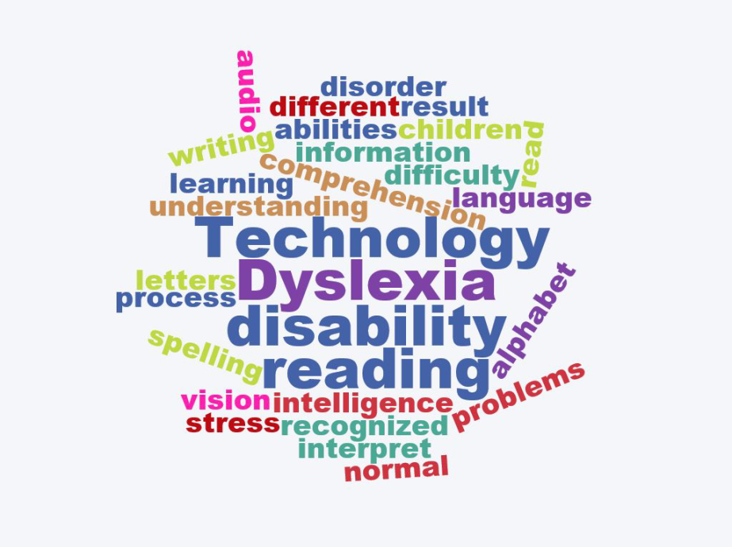

- Dyslexia section
How Dyslexia Is Diagnosed ; the test (create quiz to show the result using questions from this site : https://www.testdyslexia.com/ this site has 7 kinds of tests levels)
Please make the test using :
https://www.onlinequizcreator.com/log-in/item114
username: malketbi
password: 12345678

- Online Activities
